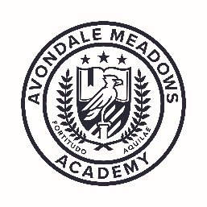
AMA Uniform Policy
2017-2018
Avondale Meadows Academy students are young professionals who are learning the habits of adult professionals, including the habits of professional dress. Full school uniforms must be worn at all times. Parents will be informed if their child is out of uniform, and will be asked to bring the proper uniform to the school immediately. If this is not possible, the student will be required to wear a substitute uniform (if available) and/or will receive a uniform violation (see back).
Monday-Thursday
Young Men:
- Khaki or navy slacks
- Black or brown belt
- White or navy polo or Oxford shirt
- White, navy or burgundy sweater or cardigan (optional)
- Black or brown, rubber-soled dress shoes (tennis shoes are not permitted)
Young Ladies:
- Khaki or navy skirt, jumper or slacks
- White or navy polo or blouse
- White, navy or burgundy sweater or cardigan (optional)
- Black or brown, rubber-soled dress shoes (tennis shoes are not permitted)
Friday
- AMA spiritwear t-shirts
- Jeans (any color but NO rips)
- Tennis shoes
*If your child is not in spiritwear, they must dress in full uniform.
Students will NOT be permitted to wear the following items in school:
- Shorts and capri pants
- Sandals (unless specified for a special activity)
- Coats, jackets, sweatshirts, or hoodies inside of the building
- Clothing bearing any logos other than the AMA logo, messages, or other insignia
- Slacks that are oversized, low-rise, baggy, or inappropriately altered
- Hats, bandanas, scarves, excessive jewelry, visible body piercings (other than ears)
- Visible body art

Questions, concerns, or uniform assistance – contact Mr. Herron at (317) 803-3182 x.5505

